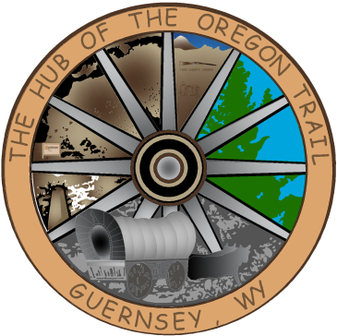

TOWN OF GUERNSEY
January 6, 2026

Liquor Protests 6:00

      - Call to Order/Pledge of Allegiance and Welcome
      - Approval of Agenda
      - Approval of Minutes –December 16, 2025

      - Consideration of Claims

      - Public Comment

      - Liquor Licenses-Kelley’s, Tony’s, Super Foods, VFW, Ben’s

      - Senator Taft Love

      - Resolution 2026-004, Banks

      - Resolution 2026-005, Newspaper

      - Community/Organization Reports
      - Department reports
      - Mayor and Council Member Reports
      - Announcements
      - Adjournment

ANNOUNCEMENTS
January 19, 2026 Townhall Closed MLK
January 20, 2026 Next Council Meeting

