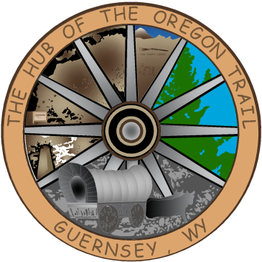

TOWN OF GUERNSEY
January 20, 2026

      - Call to Order/Pledge of Allegiance and Welcome
      - Approval of Agenda
      - Approval of Minutes –January 06, 2025

      - Consideration of Claims

      - Public Comment

      - Hub City Lease

      - Community/Organization Reports
      - Department reports
      - Mayor and Council Member Reports
      - Announcements
      - Executive Session-Personnel
      - Adjournment

ANNOUNCEMENTS
February 3, 2026 Next Council Meeting
February 7, 2026 Vet Clinic at Townhall and
Father Daughter Dance in Wheatland.
February 16, 2026 Townhall Closed for President’s Day
February 21, 2026 AG Banquet

