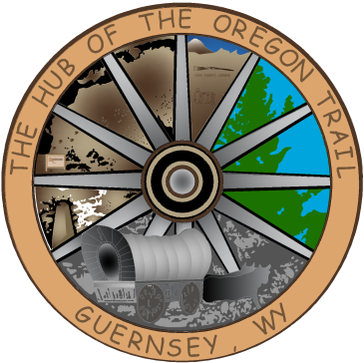

TOWN OF GUERNSEY
February 03, 2026

      - Call to Order/Pledge of Allegiance and Welcome
      - Approval of Agenda
      - Approval of Minutes –January 20, 2026

      - Consideration of Claims

      - Public Comment

      - Lodging Tax Board

      - Chamber Board Representative

      - Sewer Ordinance 2026-005 Amendment-1st Reading

      - Swim Pool Repair

      - Community/Organization Reports
      - Department reports
      - Mayor and Council Member Reports
      - Announcements
      - Executive Session-Personnel
      - Adjournment

ANNOUNCEMENTS
February 7, 2026 Vet Clinic at Townhall and
Father Daughter Dance in Wheatland.
February 16, 2026 Townhall Closed for President’s Day
February 17, 2026 Next Council Meeting
February 21, 2026 AG Banquet

