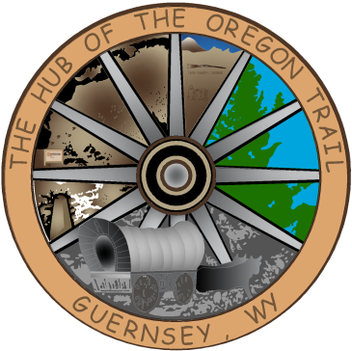

TOWN OF GUERNSEY
February 17, 2026

      - Call to Order/Pledge of Allegiance and Welcome
      - Approval of Agenda
      - Approval of Minutes –February 3, 2026

      - Consideration of Claims

      - Public Comment

      - Janelle Beck Services 4 Seniors

      - Sewer Ordinance 2026-005 Amendment-2nd Reading

      - Community/Organization Reports
      - Department reports
      - Mayor and Council Member Reports
      - Announcements
      - Adjournment

ANNOUNCEMENTS
February 21, 2026 AG Banquet
March 3, 2026 Next Council Meeting
March 21, 2026 Volunteer Fire Department Dance

