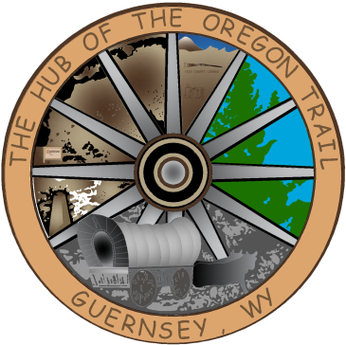

TOWN OF GUERNSEY
March 03, 2026

      - Call to Order/Pledge of Allegiance and Welcome
      - Approval of Agenda
      - Approval of Minutes –February 17, 2026

      - Consideration of Claims

      - Public Comment

      - Sewer Ordinance 2026-005 Amendment-3rd Reading

      - Chamber Membership

      - Catering Permit

      - Caselle Upgrade

      - Golf Carts

      - Source Water Plan

      - Community/Organization Reports
      - Department reports
      - Mayor and Council Member Reports
      - Announcements
      - Adjournment

ANNOUNCEMENTS
March 17, 2026 Next Council Meeting
March 21, 2026 Volunteer Fireman’s Ball
Budget Workshops Schedule
Applications accepted for Summer Help

