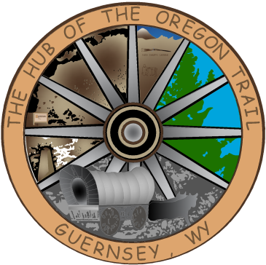

TOWN OF GUERNSEY
April 07, 2026

      - Call to Order/Pledge of Allegiance and Welcome
      - Approval of Agenda
      - Approval of Minutes – March 17, 2026

      - Consideration of Claims

      - Public Comment

      - Early Childhood-Danielle Noggle

      - PCSD #2 Athletics

      - RFP Pool

      - Water Awareness

      - Community/Organization Reports
      - Department reports
      - Mayor and Council Member Reports
      - Announcements
      - Adjournment

ANNOUNCEMENTS

April 17-24 Spring Clean up week
April 21, 2026 Next Council Meeting

