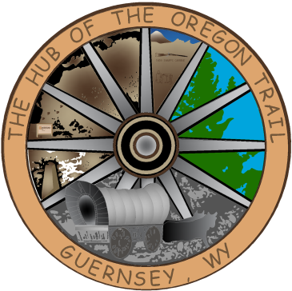

TOWN OF GUERNSEY
April 21, 2026

      - Call to Order/Pledge of Allegiance and Welcome
      - Approval of Agenda
      - Approval of Minutes – April 07, 2026

      - Consideration of Claims

      - Public Comment

      - Tri-City Parks and Rec.

      - Resolution 2026-009

      - Resolution 90 Day Corrections

      - Caselle Upgrade

      - PW Vehicle Purchase

      - Golf Carts

      - Water Awareness

      - Inmate Housing

      - Community/Organization Reports
      - Department reports
      - Mayor and Council Member Reports
      - Announcements
      - Executive Session
      - Adjournment

ANNOUNCEMENTS
May 05, 2026 Next Council Meeting
Budget Session April 22, 2026 Rescheduled for May 6

